**Winter Weather**

**Remember…**

*“In operational forecasting, there are always 2 seasons - the one you’re currently working and the one you’re preparing for.”*-KK

“Pattern recognition” is not an oversimplification when there is an understanding of the physical processes that determine the resulting pattern” - KK

1. **Physical Process Determining Precipitation Types**

* **Cloud Physics (crystals or super cool droplets? - evaluate soundings)**
  + For crystals to form in the upper atmosphere, sufficient moisture is required – i.e., dew point depressions 5° or less.
  + Temperatures at 500 mb must be -10 °C or colder for crystallization
  + 500 mb temperatures warmer than -10 °C (but still below freezing) results in super cooled water droplets
  + However, some particulate matter (such as red clay in NC) will allow for direct crystallization to occur at warmer temperatures (-8 to -9 °C)
  + As winter storms exit the region, dry air aloft decreases cloud tops where warmer temperatures (-8 to 0 °C) changes light snow to light freezing rain or freezing drizzle
* **Horizontal Thermal Advection (Surface to 10,000 ft.)**
  + Typically the dominant factor for determining p-type
  + Roughly half of the apparent warm air advection results in cooling due to upward vertical motion (lift)
* **Diabatic Effects** 
  + When Horizontal Thermal Advection is weak, diabatic processes determine p-types (multiple changes in p-types may well occur).
  + **Evaporative Cooling** (typically the strongest effect)
    - Characterized by soundings where the spread between dew points and ambient temperatures are far apart, and the dry air is deep.
    - First 0.10 to 0.25 inches of precipitation likely to evaporate as the atmosphere cools.
  + **Melting of snow** (about half as strong as evaporative cooling) - Melting of snow can result in a **deep near freezing isothermal** sounding. Degree of melting corresponds to the precipitation rate and can allow the snow level to reach the ground. Look for areas of enhanced reflectivity associated with melting of snow
  + **Latent heat of freezing**- As rain freezes, latent heat is released and warms the lower atmosphere. As temperatures warm to 30-32 °F, ice accrual significantly decreases. So, in the absence of sustained cold air advection, **freezing rain is a self-limiting process.**

**2) CAD along the Eastern Seaboard**

* Associated withstrong area of high pressure (polar or arctic origin) typically located over the Upper Mid-West/Great Lakes and/or Northeast portions of U.S.
* Northeasterly flow will cause build-up or **“damming”** of dense, surface-based, cold air against the Appalachian Mountains (occurs in other areas as well, such as in the lee side of the Rockies)
* Warm air overrides the surface base cold air which is blocked by the higher terrain to the west.
* The resulting cold air damming air mass becomes shallower as the cold air mass moves southward and/or eastward.
* The peripheral edge of the cold air mass marks the location of the “wedge” frontal boundary which can be a focus for the development of thunderstorms.
* **CAD Cold Air Damming Subtypes** 
  + **Classical –** characterized by significant horizontal CAA (cold air advection), typically the strongest of all 3 types. The associated “parent” is strong.
  + **Hybrid –** some horizontal CAA but not very strong (weaker parent high)
  + **In-Situ** **–** Very little or no CAA (parent high has moved away or weaken, or surface based cool pool was formed by evaporative cooling as rain falls into the surface based cool, dry air.
* **CAD Erosion Processes/Mechanisms**
  + The most likely erosion process is the passage of a front (cold front passage from west, or less often a warm front passage from southeast)
  + Significant warm air advection aloft that in time erodes the cool air from top down.
  + Daytime heating eroding a low-level cloud base (diurnal trend; CAD forms at night and then erodes during the day).
  + Warm rain falling into the cold air mass (release of latent heat)

**3) Wintery P-Type distributions and patterns of cyclogenesis**

* **Miller Type A Cyclogenesis:**
  + Characterized by a well-developed single surface low pressure area moving northeastward from the Gulf of Mexico/Deep South; usually occurs in conjunction with “classical” or “hybrid” CAD.
  + Incipient surface low may “jump” or transfer dynamics to a new surface low in the region of high baroclinicity along the Southeast US coast.
  + Produces a narrow transition zone (25-75 miles wide) between rain and snow
  + Heavy snow events are typically strong Miller A cyclones that develop rapidly with strong pressure falls over the near-shore coastal waters.

**Example of Miller A Winter Precipitation Distribution**

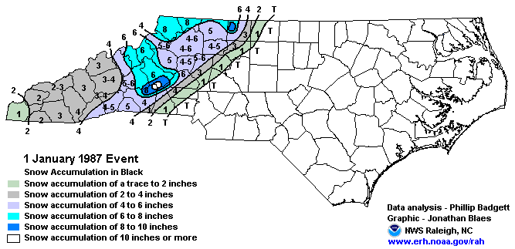

* **Miller Type B Cyclogenesis with Strong CAD:** 
  + Characterized by two surface lows forming from one incipient low, moving northeastward through the Deep South
  + The two surface lows share a warm frontal boundary and are separated by strong classical cold air damming
  + The incipient inland low weakens as it nears the Appalachian Mountains. A coastal low then develops as the upper level dynamics nears and interacts with the more favorable baroclinic zone along the warm frontal boundary.
  + The surface low off the coast can quickly become very strong (“bomb out”)
  + The Miller B pattern results in “corridors of predominate precipitation types” (snow, sleet, freezing rain, rain) from west to east across a relatively broad transition zone

**Example of Miller B Winter Precipitation Distribution**

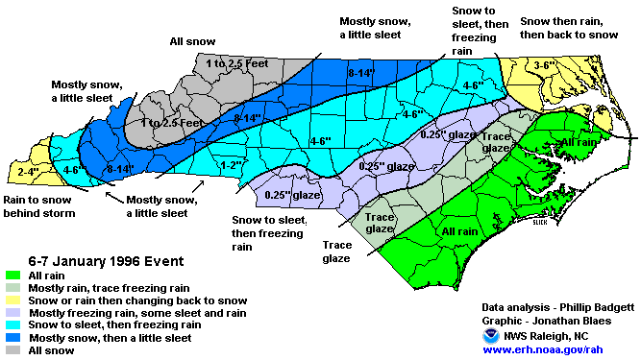

**4) Effects of Soil Temperatures and Near-Surface Lapse Rates on Wintery P-Type Impacts**

* **Soil Temperatures**
  + Measured a few inches (4-6) below the ground.
  + If >= 40 °F, ground will melt snow (occurs for some time until enough snow melt sufficiently cools soil temperatures)
  + If soil temperature is in mid-30’s (°F), not much melting will occur (doesn’t take long for snow to stick)
  + If soil temperatures are at freezing or colder, snow will immediately stick and accumulate
* **Surface Temperatures**
  + Below freezing temperatures (road temperatures 30 °F or lower) for sustained period of time will result in rapid snow accumulation on roads; heavy traffic would then worsen roads by packing the snow into a firm and slippery surface.
* **Lapse Rates**
  + Wintry precipitation soundings often show a small below freezing cold nose just above the relatively warmer surface temperature.
  + Can result in freezing rain events, where the worst accumulation is a few meters just above the surface on tree branches and power lines.
  + Foliage on trees can increase surface area for frozen precipitation to accumulate, leading to worse storm damage and more power outages (problematical for fall snows or spring snows).

**5) Winter Storm Soundings**

* **Deep Near Freezing Isothermal Lapse Rate**
* 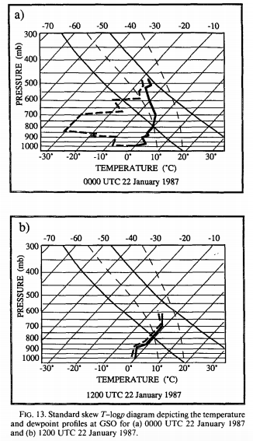
* In the absence of strong horizontal cold air advection, strong evaporative cooling can result in a deep near freezing isothermal lapse rate, supporting a wet heavy snow.
* Plentiful dry air suitable for effective evaporative cooling 12 hours prior to development of snow is shown in Figure 13a.
* Once the air mass has saturated, note the formation of the deep near freezing isothermal sounding, supporting wet heavy snow (Figure 13b).
* Coldest temperature in the lower layer resides around 850 mb and presents as a cold nose (Figure 13b).

**6) Liquid Equivalent Ratios**

* Typically, 1 inch of rain is the liquid equivalent of 10 inches of snow (1:10 ratio)
  + Very wet snows are characterized by 1:4-8 inch ratios, with temperatures hovering near freezing.
  + Dry snows generally have 1: 15-20 inch ratios, with temperatures very cold below freezing through the entire vertical column.
  + 1” inch of sleet is generally equivalent to 4 inches of snow.

**7) Wet Bulb temperatures**

* Defined as the resulting temperatures after an air mass becomes saturated due to precipitation. The wet blub temperature roughly resides about half-way between the ambient and dew point temperatures.
* Can be used to forecast the southern and eastern most extent of frozen and/or freezing precipitation.
  + Frozen Precipitation- Snow and/or Sleet
  + Freezing Precipitation- Freezing Rain

**8) Significant winter storm events include these factors:**

* **Strong Dynamics** 
  + Upper level jets (right rear entrance, left forward exit regions)
  + Concentric vorticity max plus negative tilted or closed 500 mb low
  + Parcels experience cyclonic vorticity as the travel along a highly curved trajectory.
* **Strong baroclinicity** (a tight gradient of isotherms, CAD)
* Upper level dynamics catches up with existing low level baroclinicity
* When both dynamics and baroclinic features are robust, intense cyclogenesis and heavy precipitation can occur (Peterson Equation).
* **Geographic features** (mountain barriers, lake effect snow, Gulf Stream) influence the storm evolution pattern.
* If low level lapse rates are steep (signaling **instability**), convective elements in the form of snow bands can increase the precipitation totals.

**9) Case Studies**

**January 23, 2003 Heavy snow – Strong Dynamics, Lee-side Mesolow, Coastal Low**

* Four key factors accounting for this event: **Northwest flow dynamics/lee-side mesolow/coastal low/mountain barrier**
* Heaviest snow occurred in western and extreme eastern parts of the state (heavy snowfall “jumped” portions of the Piedmont region)
* Distribution of heavier snowfall in western part of the state was a result of:
  + Strong vorticity maximum in the NW flow aloft
  + Strong upward motion associated with the right rear and left forward regions of the upper jet
  + Formation of mesoscale low in the lee of the mountains
  + Surface convergence, just SE of the mountains
  + Mountains slowed the movement of dry arctic air into the far western piedmont/foothills allowing sufficient moisture for significant snowfall.
  + Event was a dry snow (1:15 inch ratio - liquid equivalent to snow)
  + Small-scale snow bands downstream from region’s lakes (lake effect snow)
* Upper level dynamics then shifted to the near and offshore baroclinic zone, resulting in a significant coastal low with high snowfall amounts in coastal areas of NC.

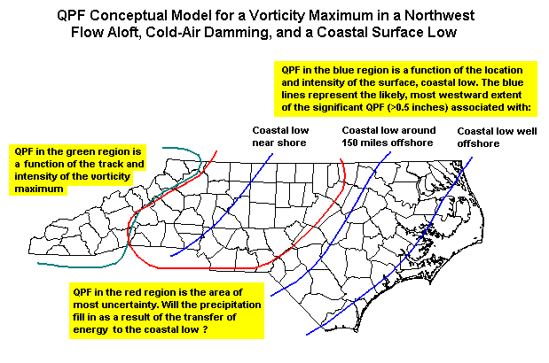

**10) References:**

1. NWS Raleigh Webpage (CSTAR)
2. <http://www4.ncsu.edu/~nwsfo/storage/cases/20030123> (Case Study Link)

**SB/KK/TF 11 November 2015**